MySQL Project Submission
Student Name: __Aanchal Karel__
Batch: _559_
Date: __23-09-2026__

QUESTIONS:
- How to identify the Records (Order ID + Product ID combination) present in data1 but missing in data2 (Specify the number of records missing in your answer)

SQL QUERY:

select d1.`order id` , d1.`product id`
from data1 d1
left join data2 d2
on d1.`order id`= d2.`order id`
and d1.`product id` = d2.`product id`
where d2.`order id` is null;

OUTPUT :
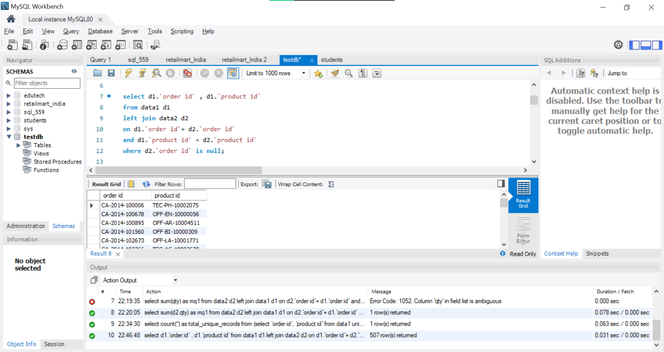

SQL QUERY:

select count(*) as md2
from data1 d1
left join data2 d2
on d1.`order id`= d2.`order id`
and d1.`product id` = d2.`product id`
where d2.`order id` is null;

OUTPUT:
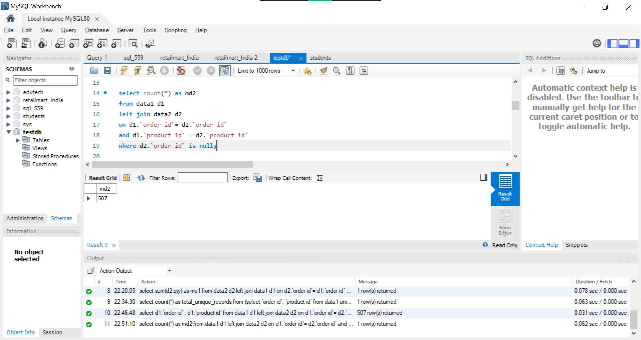

- How to identify the Records (Order ID + Product ID combination) missing in data1 but present in data2 (Specify the number of records missing in your answer)

SQL QUERY:
select d2.`order id` , d2.`product id`
from data2 d2
left join data1 d1
on d2.`order id`= d1.`order id`
and d2.`product id` = d1.`product id`
where d1.`order id` is null;

OUTPUT:
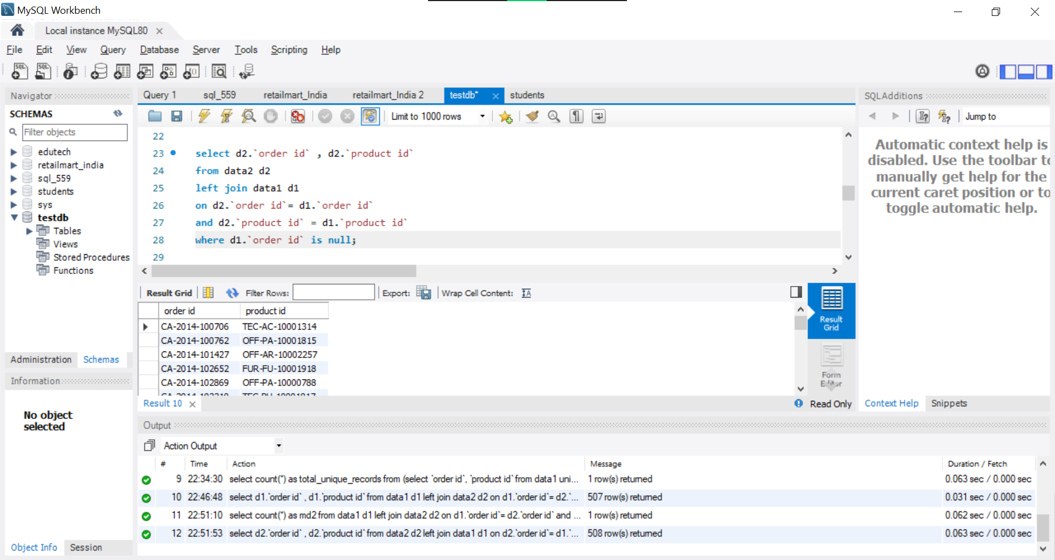

SQL QUERY:
select count(*) as md1
from data2 d2
left join data1 d1
on d2.`order id`= d1.`order id`
and d2.`product id` = d1.`product id`
where d1.`order id` is null;

OUTPUT:
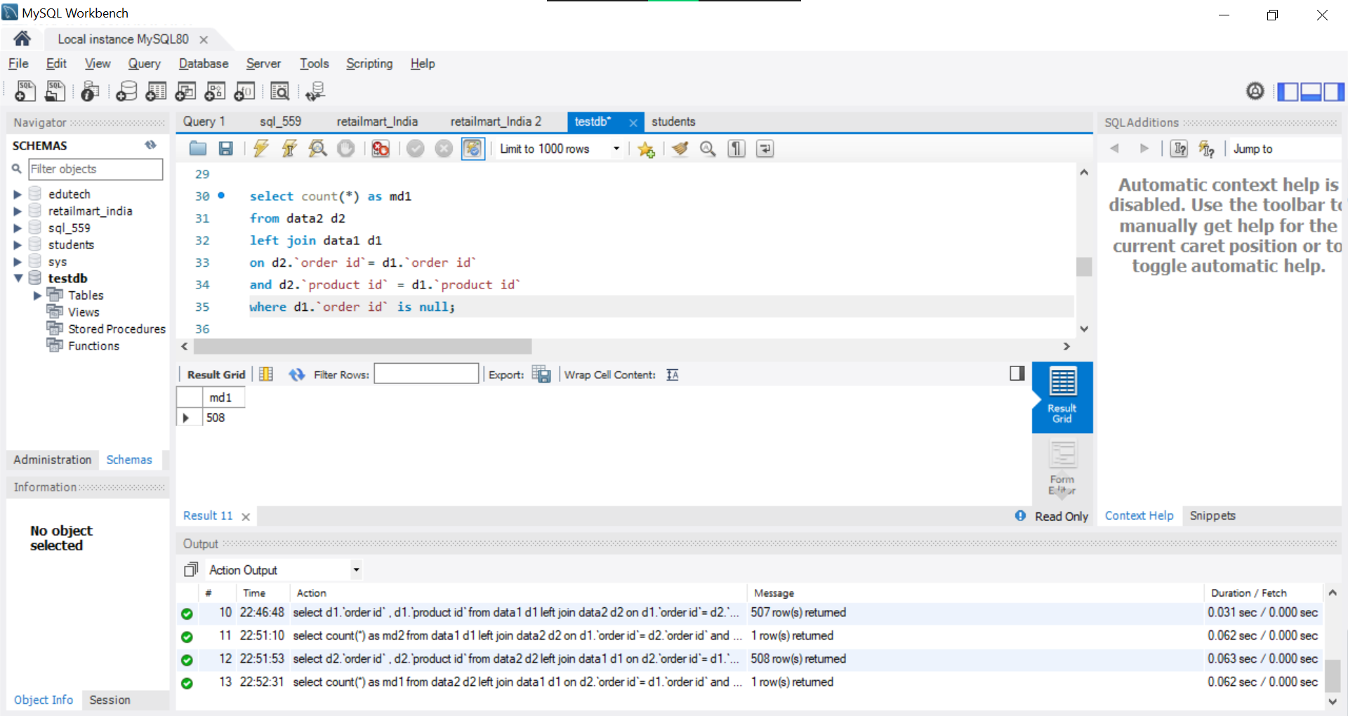

- Find the Sum of the total Qty of Records missing in data1 but present in data2

SQL QUERY:
select sum(d2.qty) as mq1
from data2 d2
left join data1 d1
on d2.`order id`= d1.`order id`
and d2.`product id` = d1.`product id`
where d1.`order id` is null;

OUTPUT:
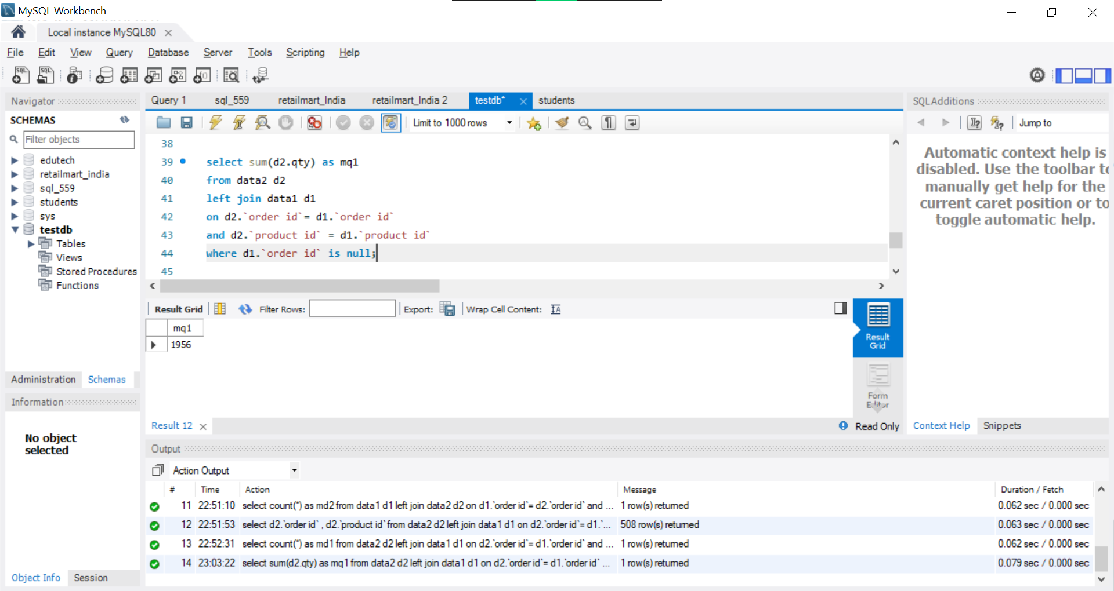

- Find the total number of unique records (Order ID + Product ID combination) present in the combined dataset of data1 and data2.

SQL QUERY:

select count(*) as total_unique_records
from (select `order id`, `product id` from data1
union
select `order id`, `product id` from data2) t;

OUTPUT:
